

|  |  |  |
| --- | --- | --- |
| Course Code and Name: CSE209& Electrical Circuits. | | |
| Datasheet no:07 | | |
| Experiment name:  DC Circuit Analysis in PSpice using Source and Resistance Sweep | | |
| Semester: Fall 2022 |  | |
| Name: D.M. Rafiun -Bin-Masud  Student ID:2019-3-60-137 | Course Instructor information:  M Saddam Hossain Khan.  Senior Lecturer  East West University | |
| Date of Report Submitted:  06-01- 2022 | Pre-Lab Marks: |  |
| Post Lab Marks: |  |
| TOTAL Marks: |  |

Circuit:

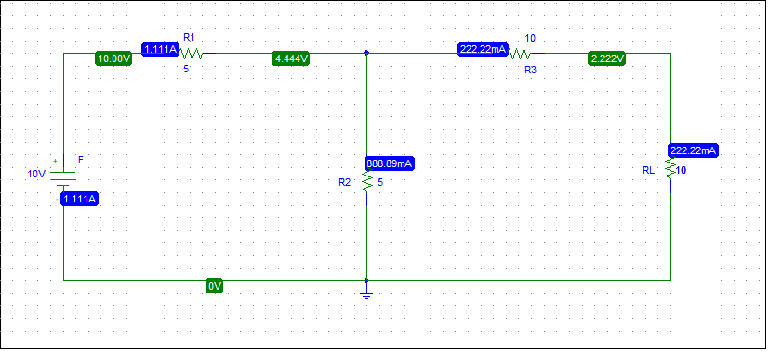

**VOC:**

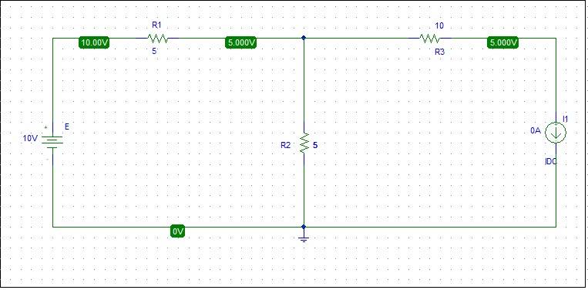

**ISC:**

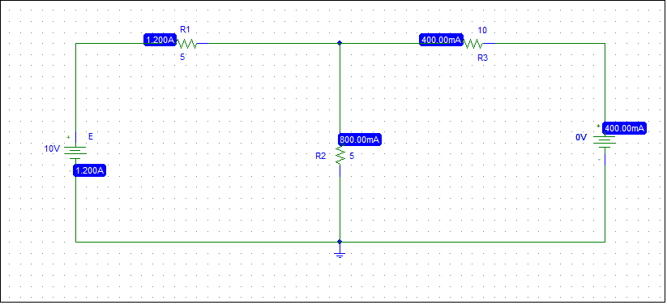

**Rth = Voc/ ISC**

**= 5/400mA**

**= 12.5 ohm**

Step 4:

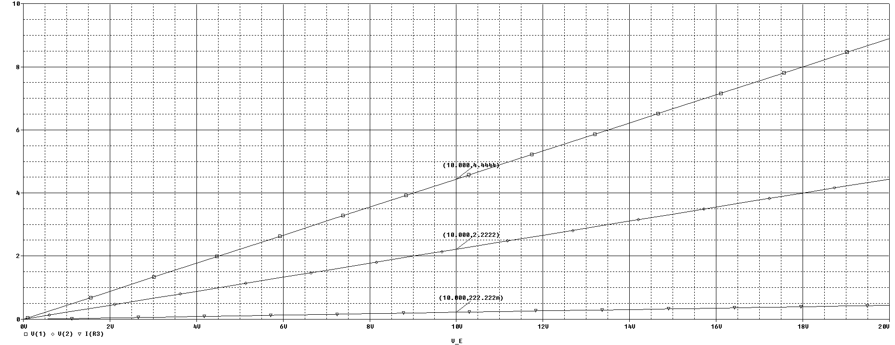

Step 5:

